Students will use their phones to go to www.chseagletime.com.
After creating an account using their school logins, the students will hit the white up arrow found at the bottom of the page.

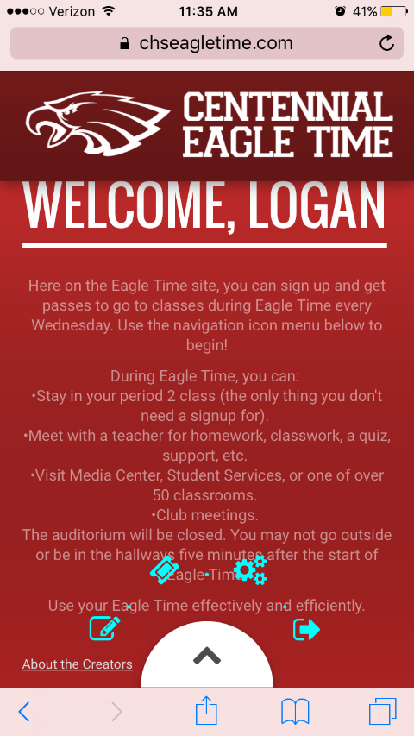 | The student will be prompted to choose between multiple icons. To sign up for eagle time, students will click on the Pencil icon.
Icons
Left – The Pencil icon is where you go to begin signing up passes
Top Left – The Ticket icon is where you do to find your current pass
Top Right – The Gears icon is where you go to adjust your personal settings. It’s only the email address for students at the moment
Right – The Arrow icon is how you sign out.
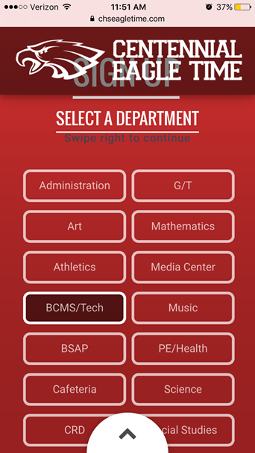 | The student will then be prompted to choose which department the teacher is in. To continue, swipe right (this also applies to computers).
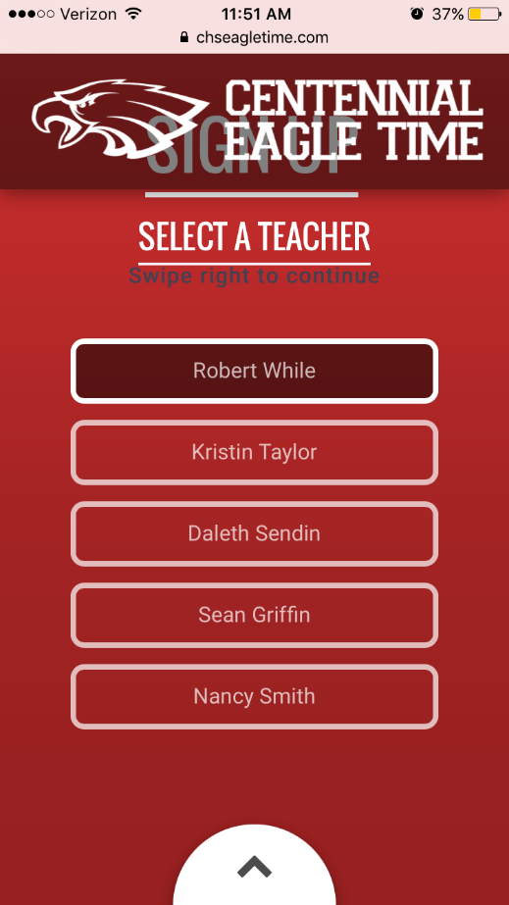 | The student will then choose which teacher they will be with during Eagle Time and continue to swipe right.
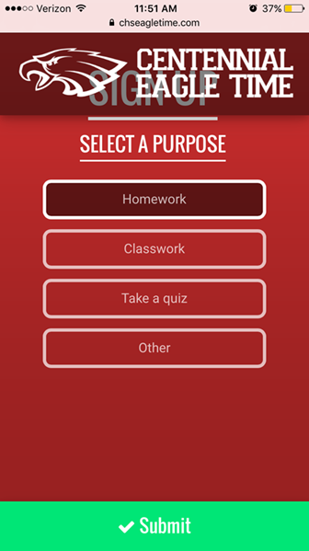 | The student will choose the purpose for being with that teacher and then hit submit in order to create a pass.
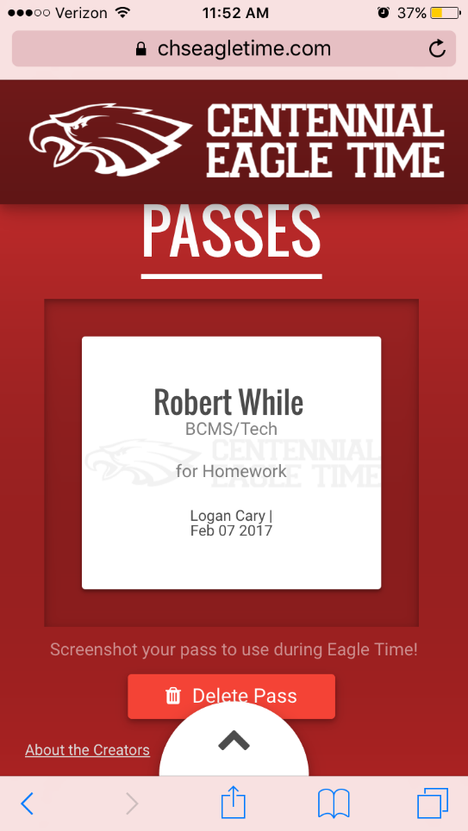 | Students will take a screenshot of this pass or sign into the website and show their 2nd period teacher.. Make sure to check the date to for the correct day. This pass can also be found by clicking on the Ticket icon

